### 

### A video surveillance system for object detection and tracking

### Version 1.0

### Participants

Ananya A Shetty

Manjari M N

**Contents :**

1. Description ------------------------------------------------------------------- 03
2. Perspective ------------------------------------------------------------------ 03
3. Product Perspective ------------------------------------------------------ 03
4. Functional Requirements for object detection---------------------- 04
5. Functional Requirements for object tracking ----------------------- 04
6. Non- Functional Requirements ---------------------------------------- 05

# 

# Description :

The System is designed to detect moving objects in a video surveillance system. It also includes features to track the path of the objects. Since, it becomes cumbersome for human operators to monitor for long durations, this System helps in detecting unusual activities that might occur in the video sequence. These systems are very useful in terms of providing security and also reduce the overhead of an individual to monitor.

## 

## Perspective :

Visual surveillance system is basically used for analysis and explanation of object behaviours. There are different methods to detect a moving object in a video. This document is intended to illustrate the processes and technical items contained by a paper on a study on video surveillance system for object detection and tracking.

**Product Perspective :**



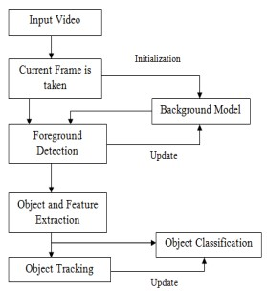

## Functional Requirements for object detection :

1. Video should be given as input to the system
2. Convert the video into a set of frames
3. Find the Difference Between two consecutive frames
4. Convert the difference image to gray image
5. Translate the gray image to binary image
6. Movement of object detected

**Functional Requirements for object tracking:**

1. Video as input to the system
2. Convert the video into a set of frames
3. Apply Foreground Detection Techniques
4. Use Background Modelling Algorithms
5. Apply Object and Feature Extraction Techniques
6. Classify the Objects (Based on features)
7. Track the path of object

## Non-Functional Requirements

(1) **Accuracy:** Results of an algorithm with respect to some reference

(2) **Robustness:** The system must be able to tolerate various conditions

(3) **Sensitivity:** Responsiveness of the system to small changes in features

(4) **Adaptability:** Dealing with variability in images

(5) **Reliability:** The degree to which an algorithm, when repeated using the same stable data, yields the same result

(6) **Efficiency:** The practical viability of the system (time and space).